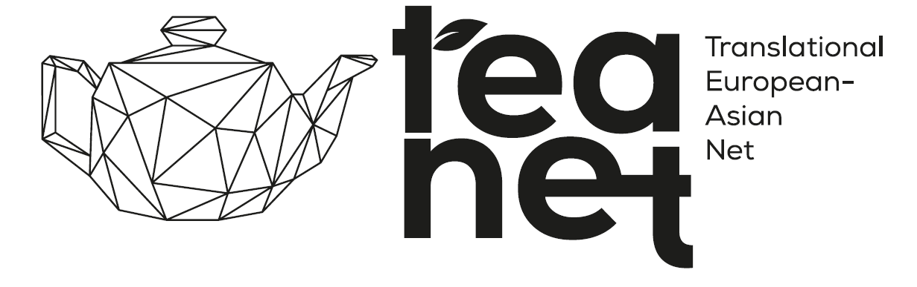
APPLICATION FORM FOR COLLABORATIVE OPPORTUNITIES
https://forms.gle/SVTKtLkqmwyJFfBD9
YOU CAN SUBMIT IT ONLY ONLINE

- Personal Information

Photo
- Full Name:
- Male/Female:
- DOB:
- Title/Position:
- Affiliation/Institution:
- Email Address:
- Phone Number:
- Address:
- MAE Membership: (yes/no)
- YAE Membership: (yes/no)
- NASE Membership: (yes/no)
- SU CTM Membership (yes/no)

MAE: Member of Academia Europaea
YAE: Member of Young Academy of Europaea
NASE: National Academy of Scientist Educations
SU CTM: Semmelweis University Centre for Translational Medicine

- Professional Background
- Degree:
- Area of Expertise:
- Key Research Interests (max. 250 words):

- Notable Publications (please list up to five):

- H-index (Scopus: if known):
- Total Citations (Scopus: if known):

- Collaboration Interests

- What specific topics or fields are you interested in collaborating on? (max. 250 words):

- Please specify your interests (tick all the relevant options):
- Bilateral research projects and research grant application
- Bilateral educational projects (MSc, PhD)
- Co-authoring publications
- Organizing/participating in workshops and conferences
- Technology transfer and innovation
- Hosting visiting researchers/students (short-term)
- Hosting visiting researchers/students (long-term)
- Sending visiting researchers/students (short-term)
- Sending visiting researchers/students (long-term)
- Working abroad (short-term)
- Working abroad (long-term)
- Other (please specify)

- Do you have a specific project idea in mind? If yes, please provide a brief description (max 250 words).

- What are your expected outcomes of the collaboration? (tick all the relevant options):
- Publications
- Patents
- Grants and funding
- New methodologies or technologies
- Student and Researcher Exchange
- Other (please specify)

5. Are you interested in sending your students to a partner institution for (tick all the relevant options):
- PhD programs
- MSc programs
- Short-term research visits
- Long-term research visits

6. Are you interested in hosting students from a partner institution for (tick all the relevant options)
- PhD programs
- MSc programs
- Short-term research visits
- Long-term research visits

7. Are you interested in visiting a partner institution yourself for (tick all the relevant options):
- Short-term research visits
- Long-term research visits

- Funding and Resources

1. Do you have access to funding for international collaborations?
- YES
If yes, please specify the source:
- NO

2. Are you seeking funding through this collaboration? If yes, what type of funding?
- YES
If yes, please specify the source/form.
- NO

3. What types of grant opportunities are you interested in? (tick all the relevant options)
- Basic research grants
- Applied/Translational research grants
- Innovation and technology transfer grants
- Educational and training grants
- Mobility and exchange grants
- Infrastructure and equipment grants
- Other (please specify)

4. Where would you prefer to utilize the grant funds? (tick the relevant option)
- Europe
- Asia
- Both continents
- Other (please specify)

V. Collaboration Logistics
1. What is your preferred mode of communication and collaboration?
- Email
- Video conferencing
- In-person meetings
- Other (please specify)

2. If financial resources are available, would you be willing to travel to an Asian partner institution for initiating the collaboration in 2025?
- Yes
- No

- Additional information

1. Please provide any additional information or comments that could help us facilitate this collaboration. (max 250 words).

- Data Sharing and GDPR Compliance

- I consent to my personal data being shared within the TEA-NET partners for the purpose of facilitating collaborative opportunities. I understand that my data will be handled in accordance with GDPR regulations and will only be used for the purposes specified in this application.

- Yes
- No

- Declaration
- I hereby declare that the information provided is true and correct to the best of my knowledge.
- Yes
- No

