Academia Europaea
‘The Academy of Europe’
General Secretariat, Room 251, Senate House, University of London, Malet Street, London, WC1E 7HU
Tel: +44 (0) 207 862 5784 www.ae-info.org

To the members of Academia Europaea

1 March 2018

Call for Nomination: Erasmus Medal - 2019

Dear Colleague,

Since 1992 the conferring of the Erasmus Medal of the Academia is a highlight of the opening session of our annual meetings. Based on nominations by the membership, the Erasmus Medal is awarded on the recommendation of the Council of AE to a scholar (preferably, but not necessary, a member of AE) who has maintained, over a sustained period, the highest level of international scholarship. The medallist is invited to give the annual Erasmus Lecture during the opening session of the Annual Meeting of the Academia.

You can read more about the Medal, the nomination and selection processes, and the former medallists on the following website:

http://www.ae-info.org/ae/Acad_Main/Activities/Awards_and_Prizes/Erasmus_Medal

The Erasmus Medal in 2019 will be awarded to a scholar working in a field belonging to our “A1” Class (Humanities).

In line with the regulations of AE, the search committee consists of the chair of the class and the chairs of the relevant sections, under the coordination of me the undersigned, in line with the decisions of the Council of the 16th of September 2013 as well as of the 22nd of November 2017.

You are most welcome to submit a nomination using the enclosed nomination form via email to me (balazs.gulyas@ki.se), with a copy to our secretariat (Execsec@acadeuro.org).

As mentioned earlier, the field of activity of the nominee should belong to a discipline covered by our A1 Class (History and Archeology, Classics and Oriental Studies, Linguistic Studies, Literary and Theatrical Studies, Musicology and History of Art and Architecture, Philosophy, Theology and Religious studies, Film, Media and Visual Studies).

The most important part of the nomination is the “case for the award” which should be comprehensive and concise, emphasising the candidate’s most distinguished achievements and her/his lifetime scholarship in the respective field, with special regard to enriching our European scientific heritage. Please keep in mind that the medallist is expected to deliver a plenary lecture at one of the future distinguished meetings of AE in front of a mixed audience and, consequently, an attractive and eloquent speaker is always welcome.

If possible, please compliment your nomination with the CV and the publication list of the candidate as well as a suggested ‘laudator’ of the candidate.
As the Board intends to make its decision about the final medallist during its meeting in late November in Barcelona and present it to the Council without a delay, the closing date of the nomination period is the 30th of September 2018.
Thanking in advance for your nomination, I remain,
Yours sincerely,
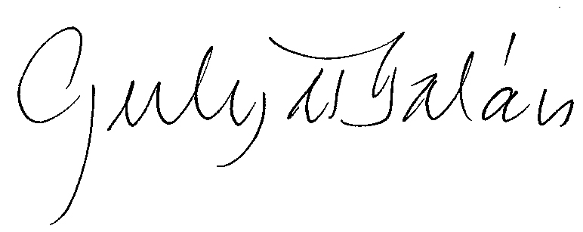
Balázs Gulyás MAE
Coordinator of the Erasmus Medal search process, Academia Europaea
Balazs.Gulyas@ki.se

Enclosure: Nomination Form

